**When we import the package, it also invokes all of the code inside the package**

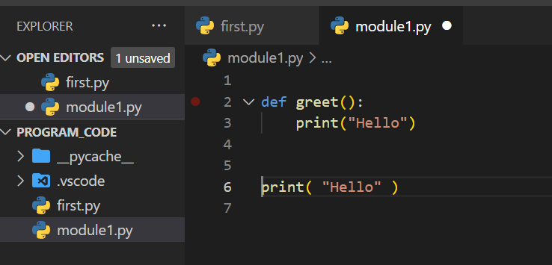

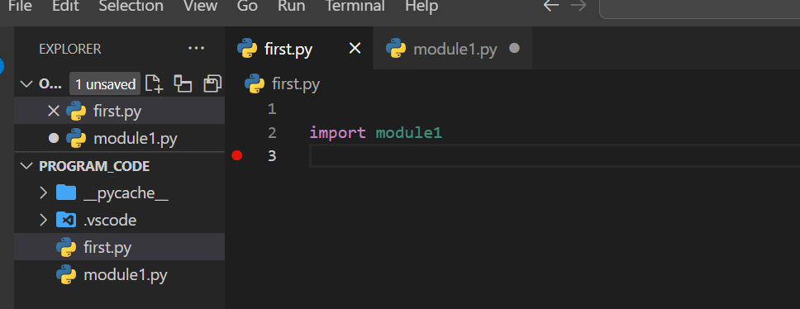

Now if we start to run from first.py

Then output will be

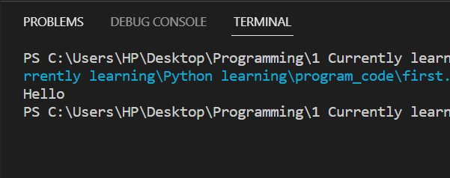

This happens because when we import the module1.py in first.py and start running first.py module then it is found that python interpreter also invokes certain types of code from the imported module also

We do not want this

There is something called **__name__ == “__main__”** for this

The python module can have any name as desired by user, and there can be any number of such modules. But the running of program starts from any one module, when the code starts to run, python interpreter **internally sets** a variable called **__name__** and sets the value of **__name__ as __main__** to the currently running module but for other module value of **__name__** is the same as the **module name**

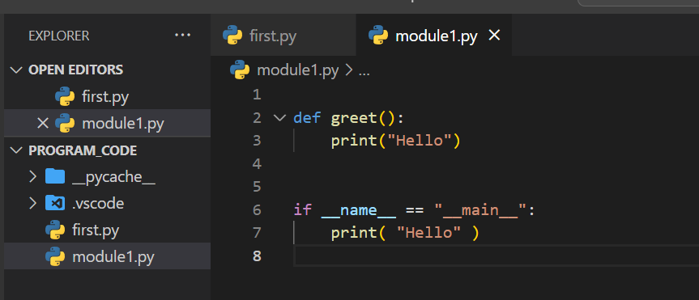



Now hello won’t be printed when the program starts from the first.py

See this below

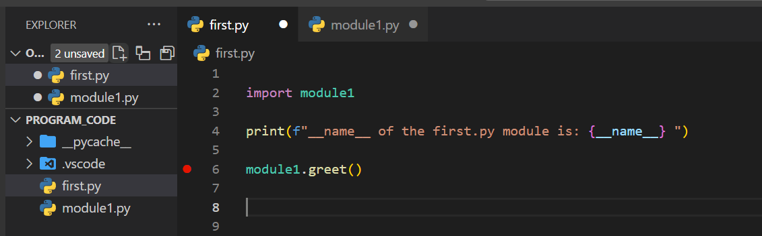

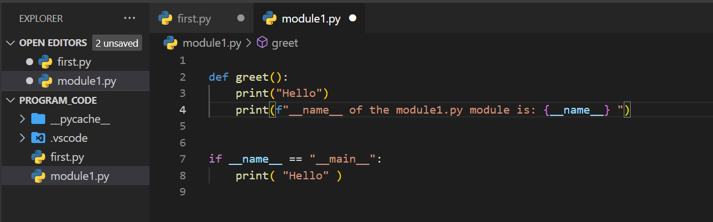

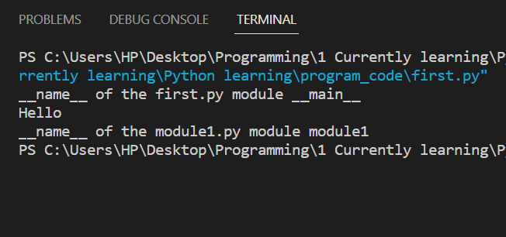

Running of program starts from the **first.py** module